SECURITIES REGULATION - Professor Guttentag - Spring 2014

This outline is formatted to fit onto the 10” X 7” pages of the 2013 Securities Reg Supplement allowed into the exam. Each page fits onto one of the blank pages spread throughout the book, including inside covers. (It might not fit if the book is formatted differently in its next edition.) Because Prof. Guttentag requires handwritten notes in the book, this will just give you an idea how much can fit onto each page so you can gauge how small you have to write to include this level of detail. Charts can fit at ends of code sections with half-blank pages (e.g. the signature page of Form S-K). What is not included here is a summary of each case, with lower circuit rulings and SCOTUS dissents, although the holdings are included throughout the outline along with appropriate code sections.
PRIMARY & SECONDARY SECURITIES MARKETS
FEDERAL SECURITIES LAW
- SECURITIES ACT of 1933 - Created after 1929 stock market crash. Regulates primary transactions:
  - Private placements, initial public offerings, seasoned public offerings, and other offerings from issuer
- SECURITIES EXCHANGE ACT of 1934 - bc Great Depression. Regulates secondary mkt transactions incl:
  - Stock exchanges, broker-dealers, proxy rules and tender offers, insider trades, NOT derivatives
- “Amendments” to the above Acts
  - PRIVATE SECURITIES LITIGATION REFORM ACT of 1995 - harder to file private federal COAs
  - SARBANES-OXLEY ACT of 2002 - post Enron / WorldCom fiascos. Changes corporate governance
  - DODD-FRANK ACT of 2010 - post 2008 financial collapse
  - JOBS ACTof 2012 - big exemptions for businesses. Legalized crowdfunding.
STATE SECURITIES LAW
- BLUE SKY LAWS - state laws largely pre-empted by ’33 and ’34 Acts, but exceptions in Rule 504 of Reg D
WHAT IS A SECURITY? - Covered under securities law, so COAs available that require less proof and in federal court
Statutory definition incl 3 categories of securities: §2(a)(1)
- Instruments commonly known as securities. (Instrument is labeled a stock, bond, debenture, etc.)
- Investment contracts (Instrument contains 4 Howey elements.)
- Instruments specified by the Act (e.g. “fractional undivided interest in oil, gas, or other mineral rights”)
WHAT IS NOT A SECURITY? - Not under securities law, so Ps would have to bring tort or K claim in state ct (or class)
- Not listed in statutory definition, construed as investment contract , or excluded bc “context otherwise requires”
- Crowdfunding (bc no expectation of profit)
- Service contract - bc not an investment. Paying for service. (ex: standalone contract to harvest fruit in Howey)
- Real estate contract (unless construed as an investment contract as in Howey)
- Timeshare (bc a purchase for consumption of an experience
- Purchase of a business (bc no common enterprise. One person buys it.)
- Transaction in which investors have to participate in work, make suggestions
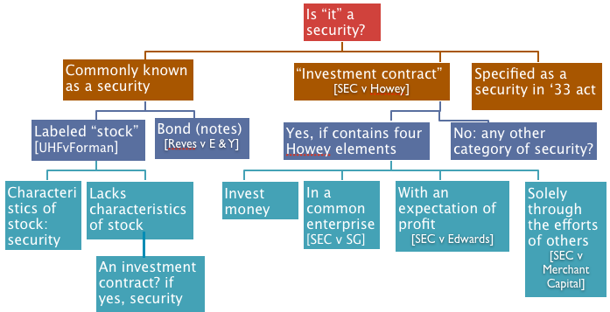
IF LISTED IN DEFINITION OF SECURITY, then go straight to whether the security needs to be registered.
IF LABELED as a COMMONLY KNOWN SECURITY, then see if has characteristics of label. It’s a balancing test.
- If YES CHARACTERISTICS OF LABEL, then it’s a security. Go to analysis of whether it must be registered.
  - STOCK - 1) Dividends depend on profits, 2) transferable, 3) Voting rights, 4) Appreciable Value
    - United Housing v Forman - Shares NOT “stock:” no dividends, non-transferable & no appreciation bc sold back to co-op for purchase price, voting rights not allocated by share
  - BOND (note) - Does it look like a note?
If YES, keep going because NOT all correctly labeled notes are securities, so check maturity:
    - Maturity < 9 mos
      - Commercial paper = NOT a SECURITY §3(a)(3)
          - Of a type not bought by general public, e.g. $1 million face value
          - Must finance current [short-term] transactions, including operating expenses or current assets (such as receivables and inventories)
          - Can’t finance fixed assets (land, buildings, equip, long-term ops)
      - If NOT commercial paper but < 9 mos. (“demand note”) UNKNOWN if security
          - but demand notes are transacted w/co itself, so primary, not public mkt
    - Maturity ≥ 9 mos., then PRESUMED to be a SECURITY unless rebutted in 1 of 2 ways:
      - FAMILY RESEMBLANCE to a COMMERCIAL transaction (i.e. not investment) consumer financing, mortgage, short-term small business loan secured by accts receivable or assets, note for open-account debt in ordinary course of business
      - Reves BALANCING TEST - 4 factors to assess the economic reality of note.
        - Motivation of buyer and seller “business use” v commercial purpose
          - Long-term uses like investment in capital assets more likely a SECURITY
            - Reves Coop sold promissory notes to raise capital for general business operations
            - Reves buyers bought to earn profit as interest
              - interest rate adjusted monthly to keep it above bank rates to ensure profit
          - For consumer good or “commercial purpose,” NOT security
            - immediate consumption, short-term use (inventory)
        - Plan of distribution
          - Widely offered and traded = likely SECURITY
            - Reves Offered to 23k members + nonmembers
          - Not widely distributed = likely NOT a security
            - Face-to-face negotiation to limited group
        - Reasonable Expectations of Investing Public
          - Reves marketed notes as investment program = SECURITY
          - Not-for-profit = likely NOT a security
        - Presence of alternative regulatory regime
          - Reves notes uncollateralized and uninsured, not regulated by any other agency, e.g. FDIC = likely a SECURITY
          - If secured, then more like banking, then NOT a security
- If NO CHARACTERISTICS of LABEL, then analyze whether it’s an INVESTMENT CONTRACT.
  - Reves promissory notes were securities as an investment contract as well.
    - Invest money? Yes, even called “investment program”
    - Common enterprise? Y, Common pool of co-op = horizontal & at least broad vertical com.
    - Expectation of profits? Y, co-op even adjusted the rate to keep it profitable for investors
    - Efforts of another? Y
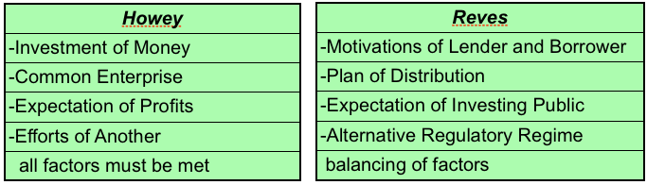

INVESTMENT CONTRACT - Broader than “stock.” NO statutory definition. SCOTUS looks at substance of transaction
The Howey Test: An investment contract is a transaction in which a person is offered to INVEST MONEY in a COMMON ENTERPRISE with the EXPECTATION OF PROFITS solely through the EFFORTS OF ANOTHER.
A land contract at a uniform price per acre of undifferentiated tracts of a citrus grove and an optional 10-yr service contract from another co to harvest the fruit was construed to be an investment contract and thus a security. Howey
- If the offer was for a land contract without a service contract, then it would NOT be a security.
  - Yes, investment of money met bc buyer pay money for financial return. See Invest Money below
  - No common enterprise bc no pooling of profits if buyers only buy the land without aggregating fruit
  - No solely through the efforts of another if buyers have to pick fruit themselves or hire a harvester
  - Yes, buyers expect a profit, so this element met.
- Even if service K were offered by an unaffiliated co, it’s still security if it’s offered at same time as land
  - Courts look at substance over form
  - Offered a bundle of rights, even if separate contracts and separate companies, really one deal.
- The service K standing alone would NOT be a security
  - No investment of money bc buying services, not financial return
  - Yes, Common enterprise (both horizontal and vertical commonality w/ common control)
  - Yes, Expectation of profit if the service provider claims you’ll earn money by letting him harvest
  - Yes, Efforts of another bc servicer harvests the land
- Even if purchasers were wealthy citrus tree company execs who knew the industry, still a security.
  - Neither the statutory definition of security nor the Howey test includes the sophistication of investors.
  - Sophistication might affect the Efforts of Another analysis if buyers can do the work themselves.
  - Sophistication might allow for a Reg D exemption so co might not have to register, but it doesn’t keep it from being an investment K and thus a security in need of registration or an exemption.
- It doesn’t matter that the service K offered was optional bc securities laws regulate offerings.

INVEST MONEY - Offerees pay money for financial returns, not a consumable commodity or service
- Howey investors paid money for financial return. They also got something tangible, but still not consumption:
  - None of them were citrus farmers so had no expertise to properly harvest
  - None even lived FL so apparently no intent to consume
- SEC v SG - arguably an investment bc possibility to win money, even if a “game.” No distinction in definition.
  - Ponzi & pyramid schemes meet Howey test, regardless if investors are deceived because the issue is whether shares are to be federally regulated, not whether they violate federal law by fraud.
- United Housing v Forman - Apt owners paid money, but arguably consumption bc getting an apartment OR arguably NOT consumption bc owners got money back paid rent, so co-op got benefit more than initial input

COMMON ENTERPRISE - Investors with similar relationship to a business in which they all invest in common.
Split: Some circuits allow vertical commonality to prove common enterprise when there no horizontal
Howey and Howey-in-the-Hills offering land & service Ks had both horizontal & vertical commonality.
IF THERE’S ONLY ONE INVESTOR, THEN THERE’S NO COMMON ENTERPRISE

- Horizontal commonality (MAJORITY) In most jx, horizontal commonality fulfills Common Enterprise element.
  - Broadest coverage:1.Broad vertical, 2.Narrow vertical, 3.Horizontal (H matches our idea of security.)
  - Investors 1) share profits and losses, which come from 2) a common pool & each investor’s share earns equal profits. If business succeeds, ALL investors earn $. If it fails, ALL investors lose $.
    - Howey co harvested entire citrus grove, and investors got a share of the net profits
      - Also, tracts weren’t distinguished from each other, required permission to enter.
    - SEC v SG all investors shared risks & profits in pyramid & ponzi scheme online “game”
    - United Housing v Forman - maybe common enterprise bc pooled money, and if co-op went under, all buyers would, too, BUT maybe not because each buyer had separate apt
    - SEC v Edwards - Ponzi scheme by definition, a pooled profit. All investors get same return
    - SEC v Merchant Capital - LLP $ not in specific pool but used to buy fractional interests in pools with other unrelated investors

- Vertical commonality - (MINORITY VIEW) - Each investor has a different deal with the promoter, so gets different slice of profits and losses than fellow investors.
  - Broad vertical commonality - Promoter does not have money in the pool, so does not share the same risk with the investors. Just need: 1) Promoter as the central link to all the investors.
    - Prof. G.’s foot device company sells shares in knee device to Pablo, toe device to Arang, and ankle device to Pedro. Investors’ profits per different deals, & from different pools.
    - “Howey same company selling both contracts”?
    - SEC v Edwards - Ponzi phone booths sold /leasedback to each “buyer” by same promoter
    - VC prevents P’s easy evasion of securities laws by paying from different pools of profits
    - BVC includes “Efforts of Another” but dependence on promoter is shared by all investors.
  - Narrow vertical commonality (9th Cir) - Same as BVC, but Promoter takes risk (is an investor) so investors’ profits are interwoven w/ Promoters’ profits. Need: 1) Promoter + 2) Promoter gets profits.
    - In above foot device company example, Prof. G is also an investor. What if only toe device
    - 9th Cir: either narrow vertical commonality or horizontal fulfills Common Enterprise
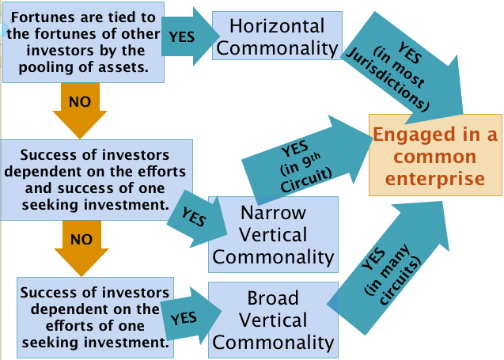
EXPECTATION OF PROFITS - Primary expectation must be profits. Starbucks investor can also consume a latte.
- Howey investors bought for financial returns from harvest, not to consume fruit itself or appreciation
    - Marketing emphasized economic benefits to be derived from harvesting / marketing fruit
- United Housing v Forman - Co-op was nonprofit, so buyers had no expectation of profits
    - Primary expectation was consumption (an apartment to live in) not profits.
- SEC v Edwards - Fixed returns = “profits” even with no promise of appreciation or dividends.
    - POLICY - Too easy to avoid registration. Protects elderly investors who like fixed returns.
EFFORTS OF ANOTHER - Securities Act meant to protect investors, not people just investing in their own business.
- “Efforts of another” per investor’s expectations @ time of investment, but economic reality trumps form.
- (efforts of another) Do Nothing-----Pick 1 orange-----Franchise-------Active (Not efforts of another)
- GP (Passive SECURITY / Active NOT)----LLP----LLC----LP (Ltd partner SECURITY / GP NOT)-----Corp.
  - LLP interest more likely security than GP bc limited liability protects partners, so passive.
- PARTNERSHIPS - Williamson presumption - partnership’s investments NOT investment Ks bc partners NOT relying solely on the efforts of another. 3 rebuttals, showing investors are relying (mostly) on efforts of another:
  - No legal control - when partners have little actual power. OR
  - No capacity to control - Partners are inexperienced or unknowledgeable in business affairs OR
  - No practical control - Partner can’t replace manager of enterprise or otherwise exercise real power
SEC v Merchant - Businesspeople inexperienced in debt pools bought partnership interests in 28 LLPs buying fractional interests in debt pools, but partnership K gave no real ability to remove MGP. Economic reality trumps form. Nominal involvement is not enough.
    - Investors couldn’t invest until they voted for Merchant, which was their only role in “mgmt”
    - Removal only for cause & by unanimity. 28 different LLPs, so all relied on efforts of MGP.
- Howey - Though not all investors bought the service K, none lived in FL, so relied solely on efforts of another.
- SEC v Edwards - Passive phone booth “purchasers.” Ponzi-er did site selection, maintenance, collection, etc.
- If investors work in business, then not an investment K bc wouldn’t profit solely via efforts of another.
  - Franchise business is not a security because the investor is runs the business.
- To avoid being a security, get an investor who can be part of the team or who can pick oranges.

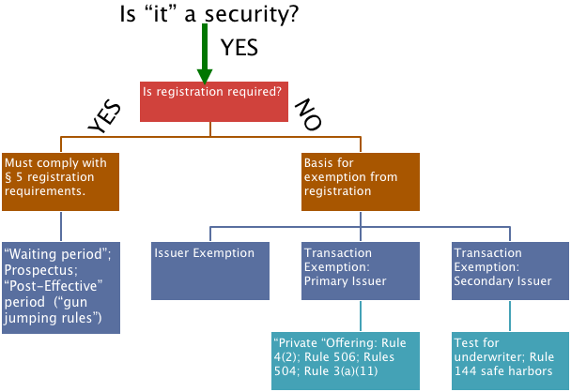

IF IT’S A SECURITY, IS REGISTRATION REQUIRED? If there’s an exemption, then no registration required.

EXEMPTIONS FROM SECTION 5

SECURITIES EXEMPTED BY § 3 BUT STILL SUBJECT TO §10b-5 LIABILITY of the ’34 Act
- Any security issued by the U.S. §3(a)(2) govt bonds
- Commercial paper §3(a)(3) note with maturity of < 9 mos.
- Intrastate securities §3(a)(11) - see PRIMARY OFFERING EXEMPTIONS & Rule 147 SAFE HARBOR below
- Offerings ≤ $5 million §3(b)(1) SEC makes these rules, not Fed Statutes. see Reg D Rules 504 & 505 below

PRIMARY OFFERING EXEMPTIONS
- Regulation S – Exempts transactions outside US (buyer or exchange is offshore). No directed selling in US.
- Intrastate securities §3(a)(11) (Only works in CA) - Securities Act Release 4434 + Rule 147 SAFE HARBOR
  - Offered and sold only to residents of state. Buyer and seller must be in state.
    - Must “come to rest” in-state (incl. subsequent buyers) before resold to out-of-staters.
    - Principal residence in-state on tax forms. Must hold for 9 mos.
  - State must be where issuer is incorporated and doing business
    - Predominant income-producing, operations in-state, not just bookkeeping or stock record
    - Principal office + 80% gross revenues & assets in-state
  - Proceeds must be for in-state activities
    - 80% of proceeds must be used in-state
  - Out-of-state offers may be integrated with a §3(a)(11) offering
    - Offerings occurring > 6 mos before or after an intrastate offering won’t be integrated

- §4(2) “transactions by an issuer not involving any public offering” (but no statutory definition provided)
  - SEC factors to determine a “Public offering” - General Counsel Opinion of 1935
    - # offerees
    - relationship of offerees to each other and to the issuer
    - # units offered
    - size of the offering
    - manner of the offering
  - SCOTUS changed test from “public offering” to “whether purpose of Act is served” Ralston Purina
    - SCOTUS says PURPOSE is to allow transaction to proceed if investors could get same info that would be in a registration stmt. PROF: But Ct forgets that sometimes disclosure is required for reasons other than just providing information, such as deterring corruption.
      - SCOTUS rejects SEC’s factor “# of offerees” - Purina
        - Offer to 500 “key” employees (out of 7k) w/o solicitation = PUBLIC.
        - Even if co offered stock to a million people, SCOTUS would still ask whether the purpose of the statute is being served
        - Offer to 4-8 sophisticated investors, 1 buyer may be PUBLIC. Doran
      - SCOTUS TEST - Can OFFEREES (not just purchasers) “fend for themselves?”
        - Purina
          - “executive personnel with access to the same kind of info in a registration statement” e.g. not a bakeshop foreman
        - Doran
          - ACTUAL INFO that would be in a registration statement OR

          - ACCESS to the information via
            - Employment or Family or
            - Bargaining power (ex: sole source of financing)
          - AND SOPHISTICATED
            - only if offeree DIDN’T get ACTUAL INFO
          - Even if only 4-8 offerees and only 1 buyer, if buyer got too little info, then regardless of sophistication, it’s PUBLIC.
      - If 1 offeree is gets no info or lacks sophistication & access, then PUBLIC.
      - If unsophisticated investors get all info or are never contacted, then PRIVATE.
  - Basically, SCOTUS created an alternative path: If offerees get comparable information to disclosure required under §5, then issuer need not comply w/ gun-jumping rules (waiting periods…)
    - If co violates §5 waiting period, co can argue offerees got all info, so offer’s exempt §4(2).
- Regulation D –Safe Harbors to avoid SEC enforcement actions & courts deciding if an offering’s public for:
  - §3 “offerings ≤ $5 million” [Rules 504 & 505]
  - §4(2) for “not a public offering” [Rule 506]
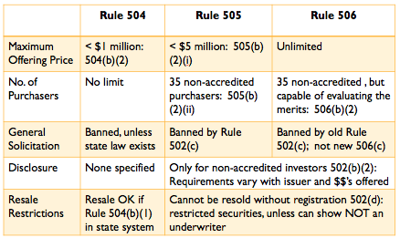
  - Maximum offering price
    - R504 $1 million R505 $5 million R506 unlimited
    - Securities sold within 12 mos before the start of an offering under either R504 or R505 are aggregated so total offering can’t exceed $1 million for R504 or $5 million for R505, even if earlier-issued securities are under R504 and the later-issued under R505, or vice-versa.
  - Number of purchasers
    - R504 no limit R505 35 non-accredited R506 35 non-accredited & sophisticated
    - Sophisticated non-accredited investors in R506(b)(2)(ii) have knowledge & experience in financial matters to evaluate merits & risks of investment OR have financial advisors.
    - Calculating number of investors R501(e)
      - Corporation, partnership or other entity
        - If ONLY has ACCREDITED investors = 0 buyer R501(a)(8)
        - If has NA investors & ≤ $5 million in assets = 1 buyer R501(e)(2)
        - If has NA investors & > $5 million in assets = 0 buyer R501(a)(3)
        - If formed to buy offered securities & has NA investors
&≤ $5 million assets, then count each NA investor in org R501(e)(2)
          - If ≥$5 million assets, then ACCREDITED investor so = 0 buyer
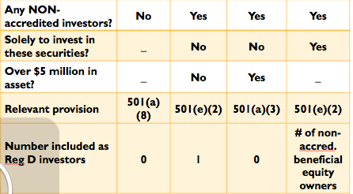
      - Don’t count: relative, spouse, or relative of spouse of buyer who lives w/ buyer, holding companies / trusts owning <50% beneficial interest, accredited investors
    - Accredited Investors – R501(a) – not included in cap for investors under R505 and R506
      - Various financial institutions R501(a)(1)
      - Corporations with >$5 million in assets. Orgs w/ only accredited investors
      - Directors, executive officers R501(f), general partners of issuer R501(a)(4)
        - Exec Officers = P, VP in charge of a principal business unit [VP of research] or other officer w/ policymaking function [VP of HR]
      - Natural persons who at the time of purchase: R501(a)5)
        - Net worth minus net equity in primary residence > $1 million
        - Ongoing Income > $200,000 (w/spouse > $300,000) past 2 yrs
          - YES: $1.1 million funds. No income except dividends. Rents.
          - NO: Former broker salary $2 million. $700k net. Now $7/hr.
        - R505 & Old R506: investors can just sign a statement of accreditation.
          - If issuer knows not really accredited, no reasonable belief
          - New R506 requires more due diligence as to accreditation.
  - General solicitation prohibited by R502(c) unless R504 AND state law allows general solicitation
PRE-JOBS ACT - STILL APPLIES TO 504 & 505 OFFERINGS & 506 w/ Non-A INVESTORS
    - General solicitation unless a PRE-EXISTING RELATIONSHIP exists w/ offerees. Kenman
      - Even if all offerees are sophisticated (“can fend for themselves” under §4(2)) e.g all Drs. in CA, Hughes Aircraft engineers, or Execs in Fortune 500 companies
      - If you don’t have pre-existing relationships w/ Forbes 100 billionaires, who can fend for themselves, then SCOTUS would say it’s NOT a PUBLIC offering and exempt under §4(2). But SEC would say it’s a general solicitation & IS a PUBLIC offering so no Reg D exemption or §4(2) & thus violates §5 so §12(b)(1) liability.
      - SEC uses “pre-existing relationship” as proxy for “private offering.”
    - Pre-existing relationship must allow issuer to know offeree’s FINANCIAL WHEREWITHAL. Insurance won’t know clients’ financial acumen. SEC No-Action Letter Mineral Lands
      - NO: Life insurance broker doesn’t know if clients have financial acumen.
      - BUT 504 doesn’t require investors to be sophisticated, so not even purpose of it
      - Under this test, you can solicit someone with whom you have a pre-existing relationship and whose financial situation you know even if you know they’re broke or NOT sophisticated. If you only suspect they’re broke, you can’t solicit.
    - Issuers hire brokerage firms bc pre-existing relationships w/ clients’ & know their financials
POST-JOBS ACT – R506(c) and §4(b) NOT IN SUPPLEMENT - ONLY FOR 506 OFFERINGS
A general solicitation won’t be a public offering no matter who hears the offer as long as the only people who buy are really accredited investors. Now issuers are not beholden to brokerage firms bc pre-existing relationship no longer required. Congress no longer regulates offers, just sales.
    - General solicitation ALLOWED in OFFERINGS under Rule 506(c) as long as:
      - All PURCHASERS (not “offerees” anymore) are ACCREDITED INVESTORS
      - Issuer must TAKE REASONABLE STEPS to VERIFY buyers are accredited
        - DEEMED to take reasonable steps if a Natural person’s (only 1 required):
          - IRS forms show ongoing income >$200k ($300k w/spouse) past 2 yrs
          - Bank statements, etc. (assets) and consumer report (liabilities) show net worth minus net equity in primary residence > $1 million. * OR *
          - Accreditation letter from broker, investment advisor, attorney, CPA
    - General solicitation under Rule 506(c) will NOT BE DEEMED a public offering per §4(b)
    - Both NEW RULE 506 and OLD RULE 506 are available
      - NEW RULE 506: NO ban on general solicitation, so NO need for pre-existing relationships. NO non-accredited investors bc must all be ACCREDITED so NO disclosure obligations. Issuer must VERIFY accreditation, file Form D2 15 days BEFORE a 506(c) offering (if SEC’s proposed RULE 503 is enacted).
      - OLD RULE 506: NO need to verify accreditation (just sign statement). CAN use up to 35 non-accredited investors as long as pre-existing relationships regarding their financial sophistication exist. Disclosure to non-accredited investors. RULE 503 File Form D 15 days AFTER offering made under any of old Reg D Rules 504, 505, 506.
  - Disclosure required to NON-ACCREDITED INVESTORS varies by issuer & offer size
      - Non-reporting Act companies:
        - Non-financial info R502(b)(2)(A)
        - Financial info R502(b)(2)(A) [heightened reqs per higher offering $]
      - Reporting Act companies – R502(2)(ii)
    - NO disclosure required:
      - under R504 unless state law requires disclosure
      - under R505 and R506 to ACCREDITED INVESTORS
  - Restricted Resale R502(d)
    - Immediate resale is not allowed EXCEPT
      - Under R504 and offering complies with state law registration reqs 504(b)(1) OR
      - Under R505 or R506 and issuer files registration or gets an exemption
    - Issuers have affirmative obligation to make sure all buyers understand resale restriction and aren’t underwriters, so issuers must show reasonable care by: R502(d)
      - Making sure purchasers are buying shares form themselves (not underwriters)
      - Giving written disclosure of resale limitation
      - Printing legends on stock certificates
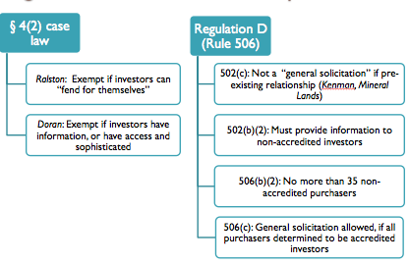
  - Decreased liability exposure under Reg D
    - No §11 liability because no registration statement is signed?
    - BUT §10(b)(5) liability STILL APPLIES whether an offering is public or private
    - No §12(b)(1) liability, if issuer complies with Rule 508
      - Rule 508 allows exemption if issuer makes insignificant compliance errors IF:
        - R508(1) – Error is in a req that DIRECTLY PROTECTS the P suing
          - Exs: Co-habitants lying about being cousins (thus 2, not 1, non-accredited investors) or issuer failing to mail disclosures to cousins doesn’t directly affect other investors, so other investors can’t sue.
        - R508(2) – Error is NOT SIGNIFICANT (e.g. one of the following):
          - R502(c) - no general solicitation – ex: mail wrong address
            - Ex: One non-accredited investor turned out not to be an employee and had no pre-existing relationship with issuer. Significant bc it violates R502(c) ban on general solicitation, so R508 won’t apply, so §5 violated, §12(b)(1) liability, & all purchasers can rescind, even if unaffected directly by error (But in practice, SEC let this slide & still allowed exemption.)
N/A: New R506 OFFERINGS to ACCREDITED INVESTORS
          - R504(b)(2)(i) – compliance with state law
          - R505(b)(2)(i) & (ii) - $ amt AND? # of n.a. investors under R505
          - R506(b)(2)(i) – the # non-accredited investors under R506
            - Ex: Exceeding # n.a. investors under R506 would per se significant, but R501 and R506 both say # n.a. investors that issuer REASONABLY BELIEVES, so no error. R508 applies.
        - R508(3) - Error is in GOOD FAITH. Reasonable attempt to comply.

- Regulation A –“Mini-public offering” updated per JOBS act RULES 251-262
  - Offerings ≤$50 million aggregated over 12-mo period (and count toward R504 & R505 offerings)
  - Immediate resale of securities allowed bc securities are registered
  - Pre-Filing period - Ability to test the waters to gauge interest
    - Written, radio & TV broadcast communication ok. Oral & other broadcast ok after submission of script to SEC. No offers or sales, or solicitation R254(a) p138
  - Waiting period communications allowed.
    - Oral offers
    - Preliminary offering circulars
    - Tombstone announcements
  - No §11 liability by signers of registration statement
  - Reduced and simplified disclosure compared with registered offering (but still req formality)
  - Can’t be reporting companies or those that have been disqualified under R262 for bad acts

SECONDARY OFFERING EXEMPTIONS
- §4(1) exempts transactions not involving an issuer §2(a)(4), underwriter §2(a)(11), or dealer §2(a)(12).
  - If no issuer (underwriter/dealer) involved, it’s NOT a primary transaction so no need to comply w/ §5.
  - Underwriter = bought from issuer: 1) w/ a view to distribution; or 2) offers or sells for an issuer.
    - A view to = purchaser’s intent is inferred from the reason purchaser resold the security
      - Shares must “come to rest” before resale. 2 yrs (probably) / 3 yrs (surely) Except
      - If funeral expenses, OK. If because investment tanks, UNDERWRITER. Gilligan
        - Must be the purchaser’s changed circumstances, not the issuer’s.
    - Distribution = PUBLIC OFFERING into the broad mkt (ex: stock exchange) per Gilligan
      - If resale is PUBLIC, then DISTRIBUTION so “underwriter” & must comply w/ §5.
      - If resale is PRIVATE, then NOT distribution, NOT underwriter, exempt from §5.
        - “PUBLIC OFFERING” defined by §4(2) case law BUT NOT REG D*
          - Purina - sophisticated investors can fend for themselves
          - Doran - investors with actual information OR sophisticated investors w/ power to have access to info (e.g. officers)
          - Private: to investment bank, but not “accredited investors”*
      - imaginary §4(1 ½) To be exempt under §4(1), “not an issuer, underwriter, or dealer” you can’t be an underwriter as defined in §4(2) “transaction by an issuer not involving a public offering,” as interpreted by case law, NOT Reg D.
      - If securities were originally issued in a registered offering, then resale w/ view to distribution is ok bc shares are already on public market, so no info asymmetry.
    - For an issuer = could just be helping, doesn’t have to be directly involved in transaction
      - Chinese Consolidated Benevolent Assoc. inadvertently acted as an underwriter
        - Transaction involved the issuer, so CCBA could be an underwriter.
        - Though CCBA had no ties, its actions were for benefit of the issuer
        - Made systematic, continuous solicitation & collection & remission of $
          - News editorial promoting bonds isn’t continuous, systematic
          - If CCBA hadn’t dealt with the $, then maybe not underwriter
      - CCBA was an underwriter, so §4(1) exemption didn’t apply, so violated §5.
- RULE 144 – SAFE HARBOR from being deemed an “underwriter” so as to qualify for §4(1) exemption from §5
  - Affiliate = person who directly / indirectly controls / controlled by / common control w/ issuer.
  - Restricted Securities = unregistered securities from issuer via private offering / transaction(s)
    - If seller is NON-AFFILIATE, and security is NON-RESTRICTED, then purchaser has no restrictions on resale bc shares are registered (disclosures) and already in public market.
  - Purchaser in a Rule 144 transaction will receive securities that are NOT RESTRICTED.
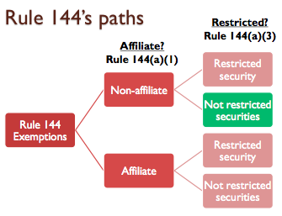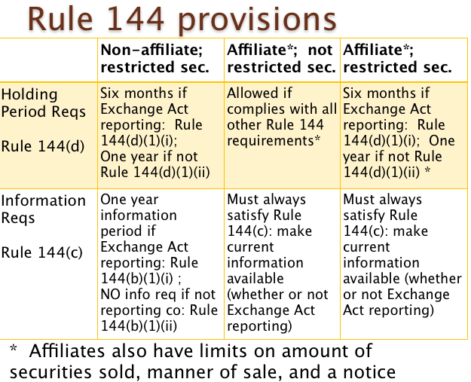
  - Holding period R144(d) measured from later date when acquired from issuer or affiliate
    - For reporting co: 6 mos. if co’s filings current 12 mos. for both Non-affiliates & Affiliates*
      - 1 yr: Non-affiliates trade w/o restrictions 144(d)(1(ii). Affiliates w/ info reqs.*
      - If IPO 6 mos ago, then filings < 12 mos so must hold 6 more mos before resale
    - For non-reporting co: 1 year - Non-affiliates trade freely. Affiliates w/ limits (see chart)*
  - Information R144(c) - Really only applies to Affiliate resales.
    - NO info reqs for NON-AFFILIATES for NON-REPORTING co if held for 1 yr. R144(b(1)(ii)
    - There was originally no info req in statute or case law, but SEC put one in its safe harbor.
- RULE 144A – SAFE HARBOR from §5 letting QIBs buy/sell in alt. mktplace. NO holding period, so LIQUID.
  - Resale only to QIBs, NOT to issuer. Issuer must use §4(2) for sale to initial purchaser.
  - Qualified Institutional Buyer - 144A(a)(1) “entity . . . owns & invests on a discretionary basis ≥ $100 milion in securities of issuers not affiliated w/entity.” such as dealer, inv. co., bank 144(d)(1)
  - Sellers must provide Notice to buyers of exemption from §5 144(d)(2)
  - Non-fungible - security specific to144A transaction not publicly available. e.g convertible 144(d)(3)
  - Information 144(d)(4)
  - Non-integration - transactions in this marketplace won’t jeopardize other exemptions 144(e)
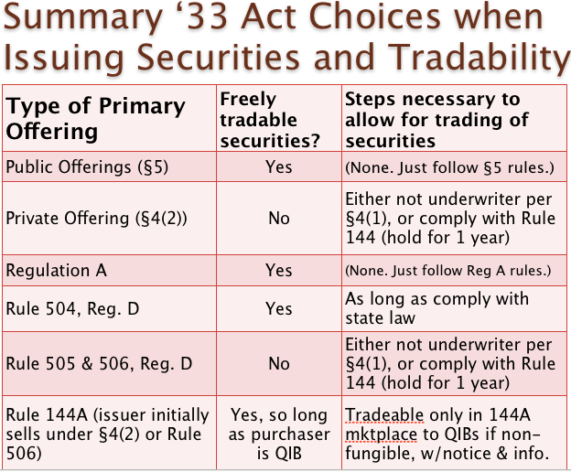
REGISTRATION OF SECURITIES IN THE PRIMARY MARKET §5 of ’33 ACT (GUN-JUMPING RULES)

If NO EXEMPTION is AVAILABLE, then it’s a PUBLIC OFFERING and MUST COMPLY with §5 REGISTRATION reqs.
Company hires underwriter as a source of financing. Managing underwriter lines up a syndicate of investment banks to buy on offering day. Minutes before opening bell, underwriter signs firm commitment (# shares, discount, spread) to buy shares and sells them immediately to syndicate, which sells to investors. Lawyers advise on structuring securities, board, corporation, pricing and help w/ registration. If IPO shoots up on opening day, issuer left $ on the table, but there’s a tendency to underprice firm commitment offerings because: Underwriters might try to limit their risk or sell shares cheap to institutional inv. buddies who then profit, to avoid lawsuits by preventing IPO from tanking, liquidity. Alternative offerings: Best efforts - investment bank acts solely as a selling agent, earning commission on sales. Direct Public Offering - Issuer sells directly to public (usually as rights offering to existing SH). Dutch Auction Offering - No fixed offering price. Investors bids for # , $ of shares. Issuer picks highest price that sells out the offering.
Costs of going public: underwriter’s discount (7%), attorneys / accountants / printing ($1-$3 million), ongoing costs of filing, risk of takeover or getting sued, distraction of management, restructuring of corporation to prepare for IPO.
GUN-JUMPING RULES
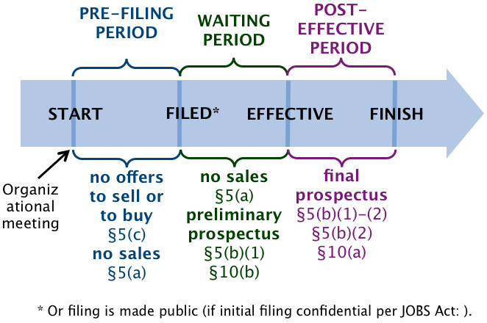
IS COMPANY “IN REGISTRATION?”
PRE-PUBLIC FILING PERIOD “In registration” Starts when issuer tells underwriter to proceed. Ends with filing reg stmt.
POLICY: prevent co from conditioning market when no one else knows yet it’s doing a public offering.
- NO SALES or DELIVERIES for purposes of sale §5(a)
- §5(b) any kind of written doc is broadly defined to count as PROSPECTUS incl video. Prospectus must be in form of §10(a).
IS COMMUNICATION AN “OFFER” UNDER §2(a)(3)?
- NO OFFERS to buy or sell §5(c) §2(a)(3) definition of “offer” broader than K law but excludes underwriter
  - CONDITIONING THE MARKET Factors: SEC Act Re. No. 3844
    - Motivation of the communication
      - Was it prearranged before the financing decision (NOT designed to condition)
      - Is it sent out by the underwriter? (YES conditioning)
    - Type of info - forward-looking info about the issuer or the industry (e.g. press releases)
      - Info not reliable enough to include in a prospectus (“Things are good.”)
    - Breadth of distribution - broader more likely an offer (mass media)
    - Form of communication - broadly distributed like written, electronic media (Oral is better)
      - Talk scheduled before trigger OK, but distributing the powerpoints for it NOT ok
    - Names the underwriter (even w/o naming issuer or stock) or facts about the offering
      - (Worst: Interview w/NY Times: “Our biz looks so good we talked w/Goldman.”)
  - REPORTING COMPANIES - CAN file periodic disclosures & run its biz SEC Act Re. No. 5180
    - Should NOT INITIATE publicity but CAN RESPOND to legitimate inquiries
    - Should AVOID projections, forecasts, or opinions re: revenue, income, earnings, value
    - Should limit communications to FACTUAL information
      - Periodic reports to SH, press release re: factual biz developments, proxy filings
      - CAN continue to advertise products and services and send out dividend notices
IN PRE-PUBLIC FILING, IF IT’S AN “OFFER,” DOES A SAFE HARBOR EXEMPTION APPLY?
  - RULE 135 SAFE HARBOR from §5(c)- short, factual notices of proposed offering NOT “offers”
    - BUT §5(a) still applies. NO SALES or DELIVERIES
    - Rule 135 may be used by ALL ISSUERS throughout ALL OFFERING PERIODS.
    - Ad must have LEGEND stating that the ad is not an offer.
    - LIMITED INFO allowed. Any MORE INFO will be an OFFER.
      - Issuer name BUT NO UNDERWRITERS
      - Title, amount, and basic terms of securities ONLY SAFE HARBOR
      - Manner, purpose & anticipated timing of offering ALLOWS TALK re OFFER
  - RULE 163A SAFE HARBOR from §5(c) - communication > 30 days before filing reg stmt NOT offer
    - Communications by ALL ISSUERS, NOT just WKSIs (but NOT UNDERWRITER or other participants) even if issuer has already met w underwriter, as long as 30+ days prior: OK.
    - CANNOT refer to the offering. Soliciting offers to buy violates 163A
    - Issuer takes reasonable steps to PREVENT DISSEMINATION of communications during 30 days (cool-down period) pre-filing reg stmt. Tell analysts stop distributing / shred docs.
    - EXCLUDES: investment of business development co, business combinations, etc. pg 83
  - RULE 168 SAFE HARBOR from §5(c) and §2(a)(10) - Public co can keep communicating as usual:
    - Regularly released FACTUAL & FORWARD-looking info by REPORTING ISSUERS only
      - and by seasoned foreign reporting issuers NOT PRIVATE COMPANIES
        - Annual 10-K report filed including info re: future risks and trends. OK
      - CANNOT be communication from UNDERWRITERS or other participants
      - CANNOT refer to the OFFERING
    - TIMING, MANNER, FORM must be SIMILAR to PAST releases in ordinary course of biz
      - Press release in reg course of biz w/ investors re: projections on profitability OK
      - Advertising in trade journals touting track record (if T, M,F similar to past) OK
      - Instead of ad, issuer sends info to institutional investors (T,M,F NOT similar) NO
      - Expand advertising to financial mags NO
    - EXCLUDES issuer that is a business development co, investment company pg 87
  - RULE 169 SAFE HARBOR from §5(c) and §2(a)(10) - Communications won’t be “conditioning” if:
    - Regularly released FACTUAL info by ALL REPORTING & NON-REPORTING ISSUERS
(Non-Reporting Issuers are the only ones who need R169 bc Reporting Issuers use R168)
      - CANNOT include FORWARD-LOOKING info. Must be factual information.
        - FWD:“optimistic re: technology” “revolutionize industry” financial future
        - FACT: Ads or info re: issuer’s products or services, business §169(b)
      - CANNOT refer to the OFFERING
      - CANNOT DIRECT information toward INVESTORS
        - Ads to trade journals may violate this unless it’s consistent w/ past
    - TIMING, MANNER, FORM must be SIMILAR to PAST releases in ordinary course of biz
    - EXCLUDES issuer that is a business development co, investment company pg 89
  - RULE 163 SAFE HARBOR from §5(c) = WKSIs’ communication won’t be “conditioning” as long as:
    - LEGEND is included to say that co is in pre-public filing period. pg 81
    - EXCLUDES business combination, business development co, investment co pg 89
    - Per Rule 405 this written communication w/ legend is FREE WRITING PROSPECTUS
HYPO 1 - CEO to cartel buddy: “I can get you in on the ground floor at around $20.”
  - No registration stmt yet, so §5(a) and (c) apply.
  - Is it an offer under §2(a)(3)? Yes bc an attempt to dispose of securities for value.
  - Does issuer have gross revenues <$1 billion? If so, emerging growth co §2(a)(19) so if buddy is QIB or affiliated investor, communication even regarding offer and price is allowed thru offering process.
  - Otherwise, any Safe Harbor?
    - No 135 bc no legend and not in writing.
    - No 163A, 168, or 169 bc references the offer.
    - No 163 bc not a WKSI.
    - Even if not an “offer” or organizational meeting hasn’t happened yet, price = “conditioning”
HYPO 2 - CEO press release re: IPO to fund R&D doesn’t name underwriter but says “well-known inv. bank.”
  - No registration stmt yet, so §5(a) and (c) apply.
  - Is it an offer under §2(a)(3)? Yes bc an attempt to dispose of securities for value.
  - Any Safe Harbor?
    - No 163A, 168, or 169 bc references offer. Even vaguely mentioning underwriter too close.
    - No 163 bc not a WKSI.
    - No 135 bc no legend and not in writing.
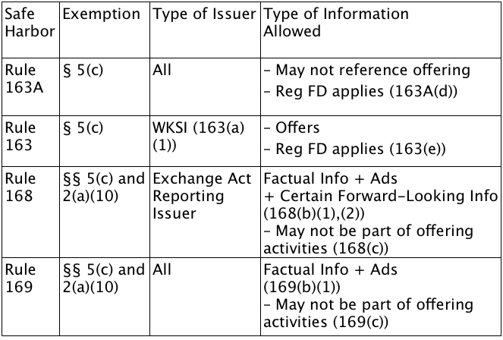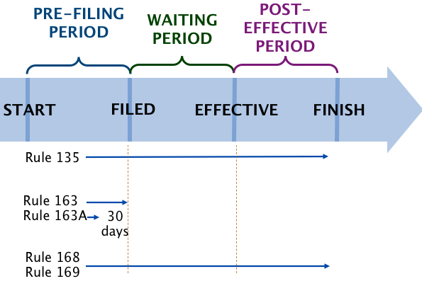
Well-Known Seasoned Issuer = reporting co w/ mkt cap (public float excl. shares held by affiliates) > $700 million p104
Seasoned Issuer = reporting co [Form S3] public ≥ 12 months AND $700 million> public float ≥ $75 million p321-22
Unseasoned Issuer = reporting co not eligible for Form S3 (public float <$75 million
Non-Reporting Issuer = non-public company
REG FD “Fair Disclosure” Rule 100(a) = If a PUBLIC company discloses material nonpublic information re: issuer or its securities to a person, it must file Form 8K simultaneously or promptly (24 hr) if unintentional. NO exception under R163 or R163A, but Exceptions: atty, investment banker, accountant, or via means listed in R100(b)(2)(iii) p564.
FREE WRITING PROSPECTUS RULE 433(b) = any written communication of an offer to buy or sell made other than by a prospectus per §10(a) “shrinkwrap” OR §2(a)(10) a note written after fiing and accompanied by current prospectus.
Issuer
- WKSI can use FWP before (R163) or after filing (R164/R433) without attaching prospectus.
- Seasoned Issuers can use FWP after fiing without attaching prospectus
- Unseasoned and Private companies can use FWP after filing but only with prospectus (link ok).
- Different rules if you’re offering debt.
Contents & Procedure
- CAN’T CONFLICT with info in the registration stmt (Form S1 / Reg SK)
- Must have LEGEND p124
- Must file FWP with SEC:
- Either no later than the first day of its use, OR
- If you’re a WKSI, you can use this FWP with legend BEFORE you file, so you just have
to keep them together so that when you file with the SEC, you attach the FWPs.
JOBS ACT allows breaks for EMERGING GROWTH COMPANIES §2(a)(19), changing process of going public
- An issuer is an emerging growth company until its total gross revenue is $1 billion (e.g. Twitter) for 5 years.
- §6(e) allows CONFIDIENTIAL draft REGISTRATION stmts to be filed. If co decides to go ahead with IPO, then 21 days before its roadshow, it must file publicly everything it filed privately, including all comments by SEC. BENEFIT: Test waters w/ SEC. Co can change its mind, & its info stays private. No one knows it failed.
- §5(d) emerging growth co issuers can communicate w/ QIB and accredited investors in all offering periods.
********************************************************
WAITING PERIOD - starts when registration statement is filed publicly and ends when reg stmt becomes effective.
- If filed confidentially, then 21 days before roadshow (formal tour of oral communications), must file publicly.
- CANNOT close the deal bc still NO SALES, even if it’s just a deposit. Cooling-off period. §5(a)
- CAN get indications of interest bc NO BAN ON OFFERS §5(c). CAN communicate by §5(b)(1):
  - PRELIMINARY PROSPECTUS - Writing allowed to be distributed during waiting period Rule 430
    - Prospectus §2(a)(10) meets reqs of §10(b). (lacks price info). Looks like reg stmt. §5(b)(1)
  - FREE WRITING PROSPECTUS - writing complies w/R433 but not §10(b) Rules 164, 405
    - Rule 433 = non-reporting, unseasoned issuers(<$75 million float) must incl shrinkwrap
    - Immaterial errors in compliance with R164 made in good faith don’t violate §5(b)(1). R433
    - Even if it’s a handwritten note, still needs legend, attach shrinkwrap, and file. R433(2)(i)
    - If non-issuer (e.g. broker), must file if broadly disseminated to large group. R433(d)(1)(ii)
  - ORAL In-person OFFERS (not radio ads, which is considered to be a prospectus)
    - If in person to live audience, it’s an oral offer, even if 1000 people or simulcast R405
      - Phone = oral. Even if puffery, it’s ok under §5 bc oral. Lies still liable for fraud.
    - His powerpoints (graphic communications) NOT considered to be “writing” bc live
audience BUT can’t let them take it home unless prelim prospectus included R433(d)(8)
      - But then powerpoint would become a Free Writing Prospectus, so it must have a legend, comply w/ Reg FD so must let all investors access that info (posted on YouTube ok), etc. but no need to file w/SEC R433(d)(8)(i) + R100(b)(2)(B)
      - If bona fide electronic roadshow (YouTube) you can’t just post slides. Must have senior manager explaining them. R433(d)(8)(i)
    - Written communications used ONLY at roadshow NOT a “writing” (oral offer) R405
  - TOMBSTONE ADS - Issuers or UNDERWRITERS put out a notice NOT considered “writing.” R134
    - Must have a LEGEND. CAN name underwriters & more info about issuer than w/ R135.
    - Anything NOT listed in R134, CAN’T be in the ad, e.g. 3 yrs audited financial stmts
    - If ad doesn’t qualify as a tombstone ad, evaluate other exemptions to see if it’s ok
  - RULES 135, 168, AND 169 ALSO AVAILABLE DURING WAITING PERIOD (see pre-filing period)
    - So companies can continue communicating as they had in the past.
HYPO - WSJ ad for upcoming IPO to “investors who want in on the new energy economy” + projection future profits.
Does this qualify as an oral offer? No bc written ad.
Is it a tombstone ad under Rule 134? No bc not factual infor per R134(a)(1). No legend.
If R134 isn’t ok, then won’t be eligible for R135, either bc it’s even more restrictive.
Is 168 or 169 available? No bc can’t refer to the offer.
168 also not available bc not a reporting company.
169 also not available bc can’t be forward-looking, wasn’t regularly released info.
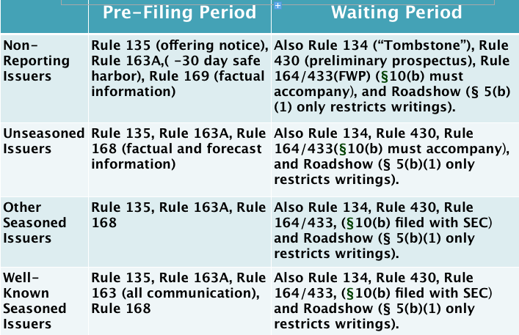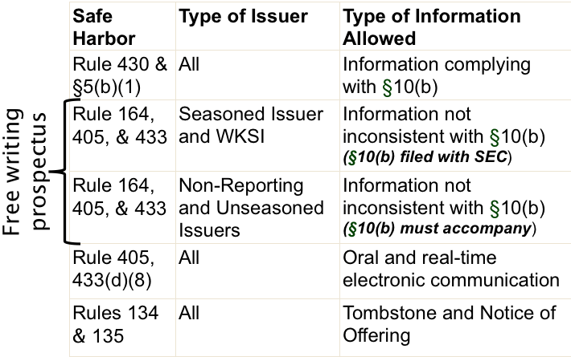

POST-EFFECTIVE PERIOD - starts when registration statement in effect §8(a)
Statute says 20 days after filing, unless the SEC decides earlier is ok. If an amendment is filed, it starts the clock over unless the SEC approves of the amendment in advance. In practice, issuer files reg stmt omitting price and Rule 430A.
notice under Rule 473 that it will seek permission from SEC not to restart clock when an amendment is filed. When SEC is ready to make registration stmt effective, then issuer files amendment w/price, and issuer goes public immediately.

Even after effective date, a sale must be accompanied by a final prospectus that includes the price. §5(b)(2) + §10(a)
Because price is set at the last moment, now price filed as an amendment to prospectus after effective date.
Secondary transaction need to supply shrinkwrapped prospectus with resale, but issuer and underwriter do. Issuer usually sells all shares to underwriter, so its obligation stops. But if underwriter doesn’t sell all shares immediately, it must continue to supply prospectus when it makes a sale, but the prospectus information goes stale.

SECURITIES EXCHANGE ACT OF ‘34

ONCE A COMPANY GOES PUBLIC, IT TAKES ON PERIODIC REPORTING OBLIGATIONS UNDER THE ’34 ACT.

DISCLOSURE OBLIGATIONS
- WHO is a public company (and thus must comply with reporting obligations)?
- Listed on a national exchange §12(a), (b)
- Deemed public by its size (per the JOBS act, current numbers thresholds are:) §12(g)(1)(B)
  - Company has ≥$10 million assets AND
  - ≥ 2000 SH of a single class OR 500 non-accredited investors (excludes employees)
- Goes public by filing registration statement under §5 of the ’33 Act. §5(d) ’33 Act
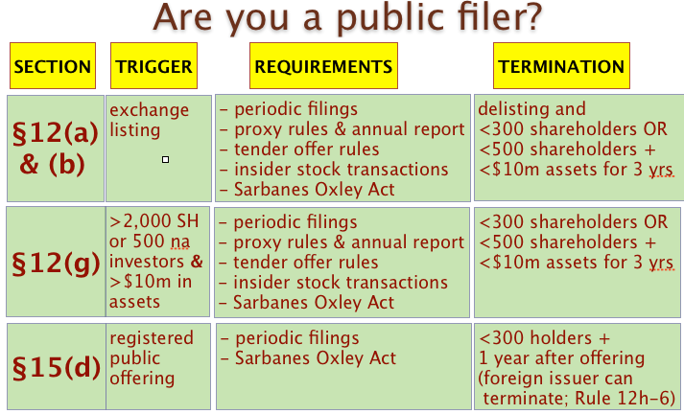
- WHEN do companies have reporting obligations?
- Form 10K - ANNUALLY Audited, and complete business description required.
- Form 10Q - QUARTERLY need not be audited but CEO and CFO must sign.
- Form 8K - Generally, no affirmative obligation to report in between periodic filings, EXCEPT when an enumerated event occurs that is deemed to be important to investors. Filed in 4 business days after (e.g.)
  - Bankruptcy, stock delisting, change in control of firm, departure of director or principal officer
  - Unregistered issuance, change in ethics code or accountant, financial stmts can’t be relied upon
  - Public announcement of material non-public info, info disclosed per Reg FD, ∆ in AOI or fiscal year
- WHAT must companies disclose? Integrated disclosure
- Regulations S-K (p171) & S-X state content for periodic reporting in Forms 8K (p615), 10K (p647), and 10Q (p662), registration in Forms S1 (p309) & S3 (p319), and proxy stmt Schedule 14A (p585)
- Some Reg S-K provisions specify that info must be MATERIAL (ex. Item 101a) or not (Item 402.a.2).
- LIABILITY FOR ANY MATERIAL MISSTATEMENTS ON THESE REPORTINGS.

LIABILITY UNDER SECURITIES ACTS

Securities EXEMPTED by §3 of ’33 ACT are NOT EXEMPT from FRAUD PROVISIONS of §17 or §10b-5 of ’34 ACT

- DISCLOSURE obligations purposes:
  - Improve share price accuracy
  - Alter behavior - “Sunlight is the best disinfectant. Streetlights are good policemen” - Brandeis
- Though a $20k loan from co wouldn’t influence a reasonable Apple investor bc co is worth billions (thus wouldn’t meet materiality standard) it would still need to be disclosed per Brandeis bc disclosure would deter such loans and other misbehavior. fn 36 in Franchard
  - Reduce preferential / insider access to information
- Hedge fund traders make more $ when disclosure threshold is low. Insiders when it’s high.

- MATERIAL - Objective judicially-created std for liability for misstatements and omissions. Threshold of disclosure. Element of all private causes of action for fraud under securities laws.
  - Info with a “substantial” likelihood that a reasonable investor would find it significant given the total mix of info available. Ct gives no guideline as to “reasonable investor.” TSC Industries

  - Whether a Forward-Looking Stmt would be important to a reasonable investor in the total mix of info = the SIGNIFICANCE of the event stated x PROBABILITY of it occurring. Basic v Levinson
    - Absent a duty to disclose (e.g. S1, S3, 10Q, 10K, 8K), a public co has no affirmative obligation to disclose. (e.g. upcoming merger: “No comment.”) But if it does disclose, it can’t lie.
      - SCOTUS says you can lie if it’s not what a reasonable investor cares about.
      - If you steal potato chips, lie on resume, borrow $ from co, just need to disclose it.
      - Potential merger material to Basic SH (bc doubled price) but probably not to acquiring co.
    - Misstatement must be about a MATERIAL FACT or else not actionable under §10b-5(b).
      - Limitation of “material fact” specific to §10b-5, but not to materiality in general.
      - Prof’s view on what could be material (e.g. meeting with customers) lies btw SCOTUS’s “material misstatement” (e.g. no merger) & 6th Circuit “any misstatement” (e.g. golf score)

  - In Efficient Markets, when controlling for all other info, if info disclosed has immediate, significant impact on price, evidence of materiality (Cir split). Info in S-1 (filed w/o $ amt) didn’t affect price til $ amt published in WSJ NOT material. [Prof: Wrong bc info made “public” in WSJ, not in S-1.] Merck
    - Quantitative factors relevant but not conclusive. (Move +-5% of net income, revenues, assets)
    - Qualitative factors can render a small misstatement material. “Earnings mgmt” of bad news.
    - Control for outside factors: Was whole mkt moving? Other big disclosures made @ same time? Info leaked already (if price didn’t move)? Move bc anticipated litigation costs? ECMH?
    - Efficient Capital Mkts Hypothesis - relationship btw information and price. 3 versions:
      - WEAK - All past public info already built into mkt price. Only new public info moves price to beat mkt. Historical info like 360-day momentum irrelevant bc already priced in.
      - SEMI-STRONG - If info is public, then already built into $. Disclosed info can’t move $. Only non-public info can move $ 3rd Circuit relied on this kind of ECMH in Merck.
      - STRONG - Even if info is non-public, it’s already built into price. No public or non-public info can move price to beat mkt, even if inside info. [WRONG bc inside traders beat mkt.]

  - Info may be material even if not useful in valuing securities or very large bc certain info will alter behavior if disclosed. If it’s about mgmt integrity, health, transaction w/co, it’s material. Franchard
    - CEO’s personal loans using controlling % of co’s shares as collateral + transfer of assets to new co are material, regardless of magnitude, bc behavior of officers important to investors.
    - Now express rules 33 Act Rule 408 (Addl Info), Reg S-K Item 402(c) (Change of Control), Reg S-K Item 404 (loans to insiders), §402 of SOX (prohibits loans to officers & directors)

- §11 LIABILITY for MATERIAL MISSTATEMENT in Registration Statement Only used if share price drops.
  - As of the day it becomes effective §8c, a reg. stmt can’t include a MISSTATEMENT of a MATERIAL FACT or OMISSION of anything that keep reg. statement from being misleading. Rule 408, §8d
  - STRICT LIABILITY. No proof of reliance or intent to misstate required. P need NOT even read S1.
  - DAMAGES = difference btw purchase price and price at which P sold, with a MAX of offering price and a MIN of current share price. Total recovery limited to aggregate offering price. §11(e)(1)
  - PLAINTIFFS’ STANDING - If material misstatement in registration stmt, Ps can be: Krim v PC Order
    - Buyers of shares that were REGISTERED or CAN TRACE to registered shares, NOT just “likely to be able to” trace, NOT issued in street name or bought in open mkt. P must buy:
- Right after IPO during lockup period so only shares publicly traded are IPO
- Direct from issuer or underwriter (INITIAL or SEASONED PRIMARY offering.)
  - Reg stmt says “Shares being sold by PC Order.”
- Direct from SH who bought from issuer (SECONDARY offering. $ to SH, not Co.)
  - Reg stmt says “PC Order offers shares sold by Trilogy [SH].”
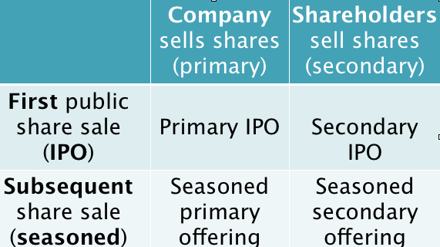
    - POLICY: protecting only traceable shares excludes other buyers who were still harmed, but 33 Act’s policy is to make reg stmts reliable at issuance, not protect secondary mkt.
    - Issuers might ABUSE system by selling only to buyers who won’t file §11 claim or won’t take possession of the shares and instead sell them into open mkt to end ability to trace.
  - DEFENDANTS Statutory §11(a) AUTOMATICALLY LIABLE Escott v BarChris
    - anyone who SIGNED the REGISTRATION STATEMENT as defined in §6(a)
- Issuer (co) always a D. Principal exec & finance & acct officers, majority of board
- Auditor (Co) signs so a D, but not the individual. (even though not listed in §6(a))
    - every DIRECTOR or PARTNER of issuer at time of filing of contested part of Reg Stmt
- Directors are still liable even if they don’t sign.
- Can be controlling SH per §15 or one who acts like Dir / Officer. Krim v PC Order
    - every ACCOUNTANT, ENGINEER, APPRAISER, anyone who CERTIFIED contested part
- Auditor liable only for certified financial stmt, not risk factor section, etc. §11(a)(4)
- Senior Accountant liable only for the part she certified.
- Attorneys NOT an expert unless hired to give a legal opinion in the reg stmt.
    - every UNDERWRITER (Co) but not individuals
  - DEFENSES Statutory Ds personally liable for misstatement / omission unless can prove:
    - Misstatement / omission was not MATERIAL §11a
    - PS knew of misstatements / omissions when they acquired securities §11a
    - If co released earning stmt > 1 yr after effective date of reg stmt, reliance must be proven
    - SOL: 1 yr after P discovers (or should’ve) misstatement but ≤ 3 yrs after effective date §13
    - WHISTLEBLOWER - ex: resigned bc found misstatement, blew whistle §11(b)(1) & (2)
    - CAUSATION, something else (e.g. phone virus, so no Kandy Krush) killed IPO §11(e)
    - DUE DILIGENCE DEFENSE - all Ds but Company can use Due Diligence §11(b)(3)
- EXPERTS NOT liable for non-expertised parts of registration stmt. §11(a)(4)
- EXPERTS must do REASONABLE INVESTIGATION of EXPERTISED
parts and have a REASONABLE and ACTUAL BELIEF they’re true (+ use GAAP)
- NON-EXPERTS have NO INVESTIGATION required for EXPERTISED parts of stmt but must have NO REASON TO BELIEVE they’re UNTRUE. (rely on repute)
- NON-EXPERTS must do REASONABLE INVESTIGATION (MUST READ) of NON-EXPERTISED parts & have REASONABLE & ACTUAL BELIEF they’re true
  - Can’t just rely on co’s oral stmts. Must insist on seeing supporting docs.
    - Then if not given damning doc, D’s off hook. But if it’s given, D’s liable.
  - INSIDERS must say they lacked actual knowledge of wrongdoing in own co & also made a reasonable investigation to claim due diligence. DIFFICULT
  - Reasonableness standard “prudent man in mgmt of his own property.” §11c
  - Factors re: if investigation “reasonable” Rule 176. Useless, so use case law
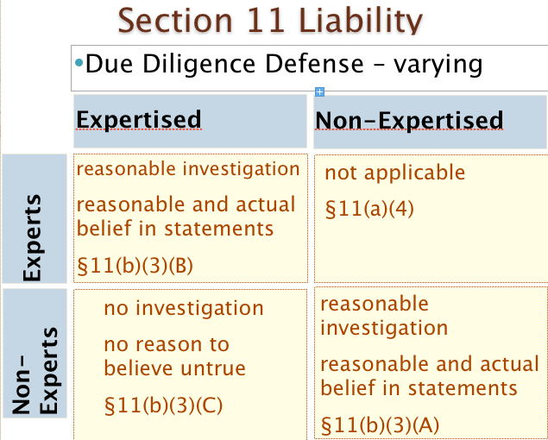

- §12(a)(1) LIABILITY for FAILURE TO COMPLY WITH §5 PROCEDURES Pinter v Dahl
  - PLAINTIFFS - buyer of shares directly from a seller who offered or sold in offering that violated §5.
    - If issuer didn’t follow §5 rules, all buyers can ask for $ back, but only from Ds who sold it to Ps.
  - DEFENDANTS Statutory - STRICT LIABILITY but D’s NOT automatically liable. P MUST PROVE that D’s “any person who offered or sold in violation of §5” (even if that means just soliciting).
    - D can be proven to be a statutory seller in two ways:
      - Passes title to buyer
If Dahl gets Friends to buy stock from Pinter, Friends can sue only Pinter bc Dahl didn’t offer or sell directly to Friends.
      - Solicits investment for co-defendant’s or issuer’s benefit
“Statutory seller includes one who successfully solicits offers to purchase securities motivated at least in part by a desire to serve his own financial interests or those of the securities owner.” If Fs didn’t buy directly from Dahl, to hold D liable, 2 conditions required:
        - That Dahl was a seller per §2(a)(3) definition of “sale”
If Dahl told F it was good stock to buy from Pinter, then may be liable bc although D has no privity w/F, if recommending = soliciting, then “sale”.
        - D’s motivation must be at least in part to serve his own or issuer’s interests, not solely to benefit buyers by providing gratuitous advice.
Not just financial benefit. D got no commission but may be on P’s team.
  - REMEDY - Recission. P recovers [loss (purchase price-sales price) + interest] from D.
  - POLICY - Shouldn’t limit Ds only to sellers who merely passed securities to buyers if other parties are soliciting on their behalf because the purpose of 33 Act is to provide buyers with full & fair info.

- HYPO §11 Ds that could also be §12(a)(1) Ds for material misstatements in Reg Stmt AND violating §5
- The Company could have both §11 and §12(a)(1) liability.
- Signers of Registration Stmt
  - CEO both signs Reg Stmt if also talked up stock (bc part of offering process & benefit)
  - OUTSIDE DIRECTOR liable only if actively involved in the marketing of securities. (Are they independently soliciting sales and are they personally benefiting?)
- RULE 10b-5 LIABILITY for MATERIAL MISSTATEMENT / OMISSION w/ PURCHASE or SALE of security
  - Using interstate commerce or mail or any use of the national securities exchange[s] to misstate/omit
  - If no offering is involved, only ’34 Act (10b-5) is available, regardless if public or private company.
  - PLAINTIFFS
    - Public enforcement - SEC can bring claims
    - Private right of action (implied)
        - STANDING - Ps who bought or sold due to lie Blue Chip Stamps v Manor
          - SH would still have standing for derivative lawsuits, just not 10b-5
          - POLICY - No record of what nonbuyers would’ve bought. Potential for abuse. Like §11 trace shares. §12 directly buy [Prof: if can prove, should get standing].
        - PROOF
          - MISSTATEMENT of a MATERIAL FACT
            - Fact “reasonable investor” would consider important in total mix of info TSC
            - Forward looking stmts material if SIGNIFICANCE x PROBABILITY Basic
            - Retrospectively a fact is material if it moved stock price significantly Merck
- NOT: if re Mr. A being a cheater, $3.7 million not $3.71 million
- Show “price impact” from misstatement by looking at $∆.
            - Info may be material if re: management integrity Franchard
          - SCIENTER
            - D affirmatively intends to mislead bc “employ/operate” imply intent §10b-5a,c
            - P must plead each act or omission w/ particularity facts giving rise to as strong inference of scienter. PSLRA (pg 406) §21D(b)(2)(A)
- “Strong” requires comparative analysis with competing inferences. Must be at least as cogent and compelling story of events as the inferences not leading to scienter. Doesn’t have to be strongest or most plausible.
          - RELIANCE - Transaction causation - P wouldn’t have bought / sold BUT FOR lie.
- NO reliance - P sold because he needed liquidity (i.e. not bc of lie)
- YES reliance - P bought knowing that D was lying (even if had no loss)
- REBUTTABLE PRESUMPTIONS of reliance when 1) omitting material info when co has a duty to disclose and 2) FOTM
- Fraud On The Market theory - In an efficient market, the lie is Basic presumed to be reflected in market price, so even if P did not know about the lie, P’s reliance on the lie is presumed bc P paid mkt price.
  - ISSUE - whether pool was muddied w/ the lie when Ps transacted.
  - POLICY - Hard for P to prove without presumption. Integrity of mkt.
  - CLASS ACTION - Common issue bc all Ps bought at mkt price
  - FOTM unstated basis - [Semi-Strong Efficient Capital Mkt theory]
          - LOSS CAUSATION - Lie causes loss (e.g. lowers price) [like proximate cause]
- If P sold at or above purchase price, no loss causation.
- Not about the inflated price but the subsequent drop (and its causes)
- Prove at trial, not class certification stage. EPJ Fund v Halliburton
  - DEFENDANTS
    - NO SECONDARY LIABILITY - direct liability for co only. [despite “or indirectly” in statute.]
        - No liability for accountants and lawyers in private suit but SEC can still bring a public enforcement action against any person who knowingly provides substantial assistance.
Stoneridge Inv. v Scientific-Atlanta
- Suppliers had no duty to disclose & didn’t draft fake docs but agreed to fake deals and forged & backdated docs to mislead the co’s accountant
- Suppliers’ lies helped (indirectly) inflate cable co’s revenues & income
- Cable investors relied on stmts of cash flow and profit from transactions
- Suppliers entered into transactions, forging dates - not preparing docs
  - DAMAGES - No cap on damages for company to pay out. P is limited to purchase price.
  - PSLRA - Private Securities Litigation Reform Act of 1995 - validated 10b-5 implied right of action
    - Rebuttable presumtion: lead P in a class is shareholder with largest financial stack in action.
    - P must plead with particularity facts leading to a strong inference of scienter.
    - Discovery can’t start until Motion to Dismiss is past.
    - Safe harbor for forward-looking statements
    - Limits liability of Ds not involved in intentional fraud to proportionate share of harm caused.
